Mkdir command is use to make directory

Mkdir –safi1.txt



In the above image I have created a Dir- demosafi1

Now I need listed out the directory which I made in the above image using **ls** command.

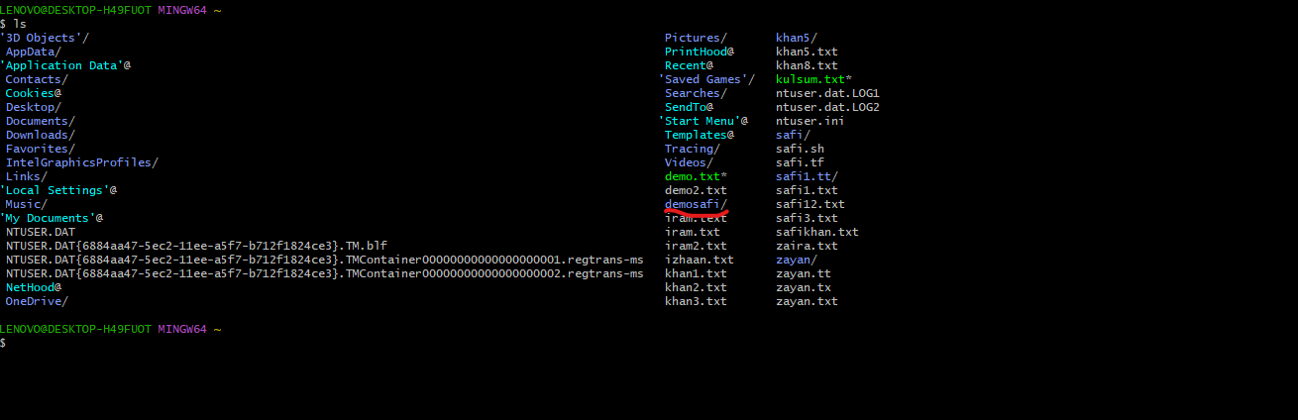

cd--This command is used to change the Directory.

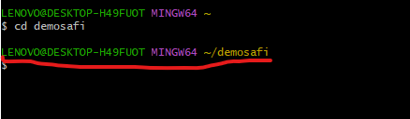

Pwd –--This command is used for to check the present work directory.

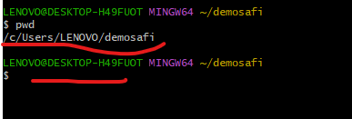

Touch--This command is used for to create an empty file.

Example -touch demosafi.txt

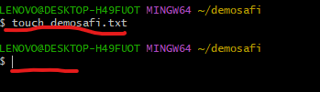

vi--(editor)This is used to write the some text/content in the created file (need to press ctrl I –to write some thing in it

Example -vi demosafi.txt

To come out use firs Esc button + shift:wq.

Aftercoming out



cat(file name)--This command is used for to check the content of the file

head (demosafi.txt)--This command is used for top 10 lines of the file (First 10 lines)

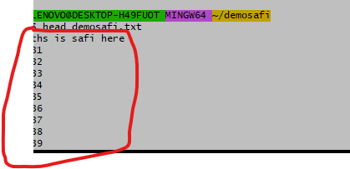

tail(demosafi.txt)--This command is used for to get last 10 lines of the file.(last 10 lines)

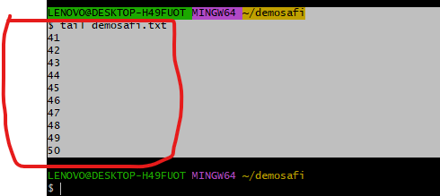

Version -git version to know the version of gitbash

rm -rf(Space hypon rf)-- This command is used for to delete the file and directories.

Merging of code from two files to third one

First create 2 files using touch command (Example touch demosafi.txt other file touch demosafi1.txt and third file demosafi3.txt

Write some thig using vi editor and demosafi.txt and demosafi2.txt- and move using cat command to the third file demosafi3.txt)

**cat -- file1.txt file2.txt > file3.txt---This command is used to move the code from file1,file2 to file3.**

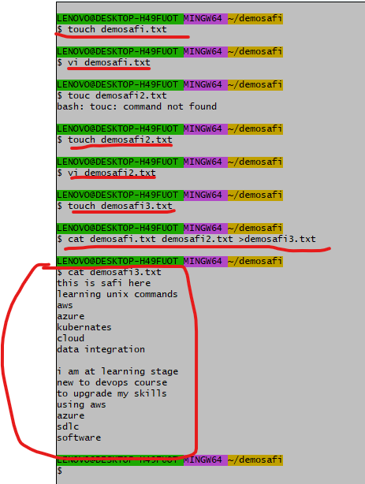

ls *.txt---This command is used to display the files which are interconnected to .txt file.

ls -R---This command is used to display all the files in sub directories.

Ls -al –it displays all hidden files- This command is used to display all the files with read,write and execute permissions

ls -a---This command is used to display all the hidden files that will start with fullstop(.)

grep -this command is used to search a code or line in a sentence.

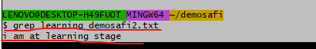

Mv command—this command is used for to move the files

Mv khan21.txt khan22.txt

Cat khan22.txt

